# Initial prototyping screen-shots:

## Prototype box concepts:

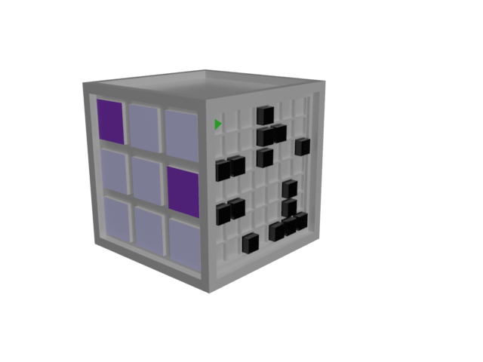

Initial concepts of what puzzles on the box would look like. The puzzle on the left of the box is an early concept of the rainbow tile puzzle present in the final version of the game. The right puzzle is an early concept of the maze puzzle, also present in the final game.

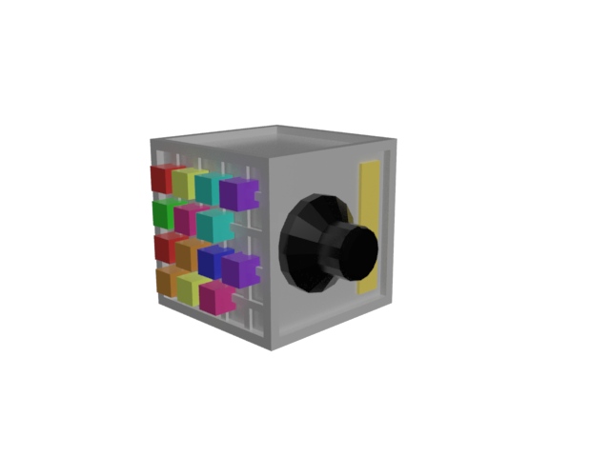

This box concept shows a development of the rainbow tile puzzle (left) and an unnamed puzzle on the right which wasn’t implemented.

First iteration of in game box and background:

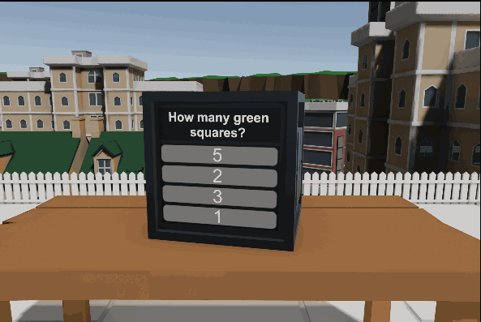

This screenshot shows the first playable version of the game. This version showcased experiments with the environment the game takes place in which was changed later on and implementation of the box of which at this stage did not have networking.

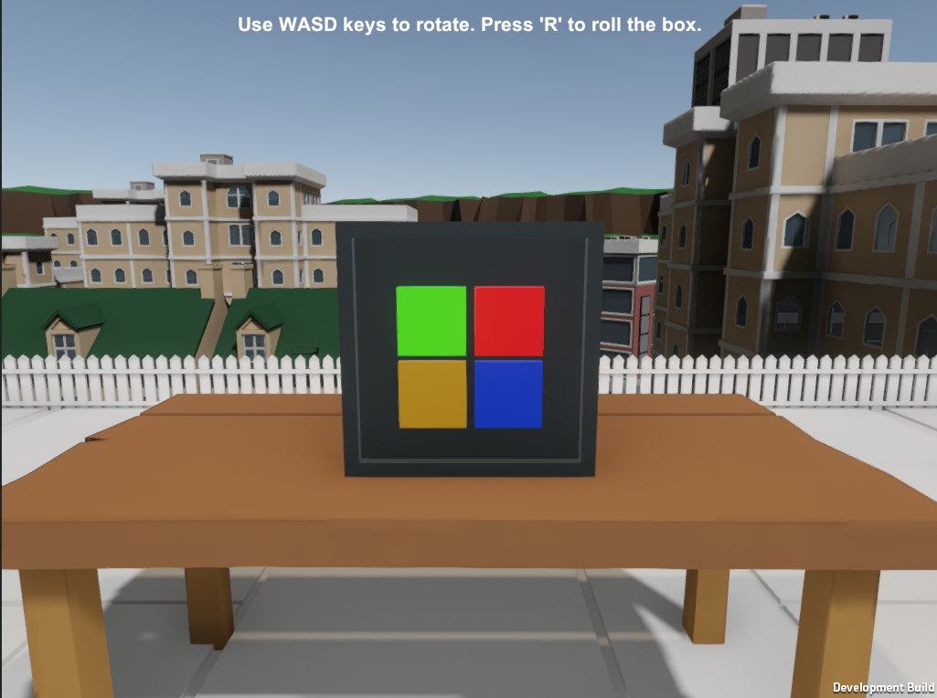

This is also the same version just showing the other side of the box with the first version of the simon says puzzle where players have to repeat a sequence.

First iteration of menu:

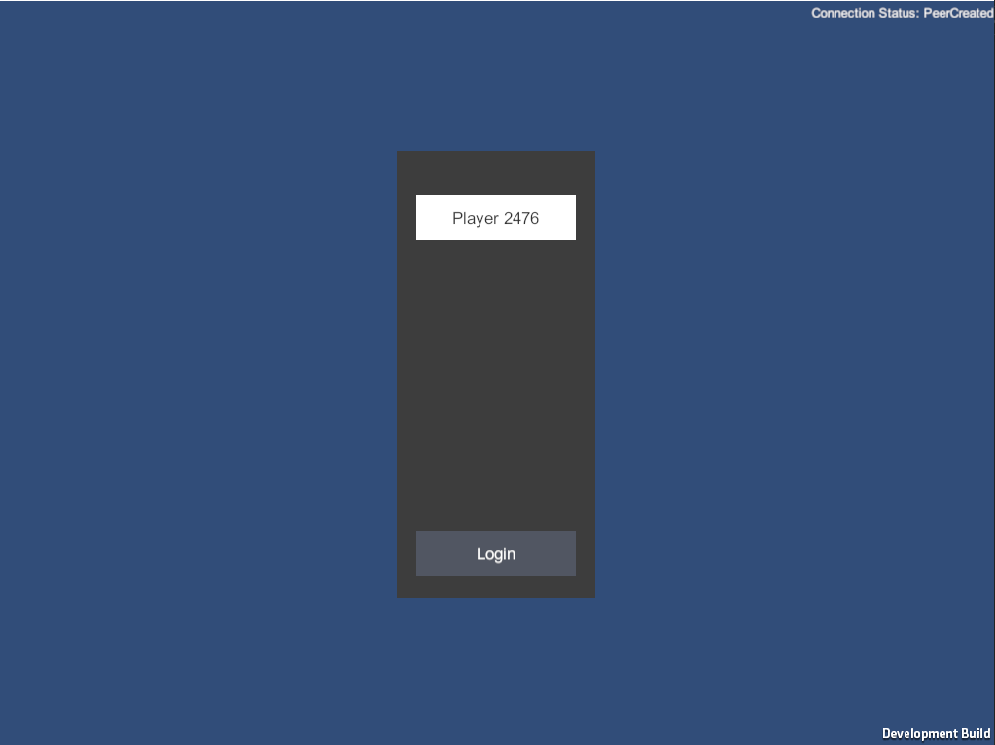

A functioning version of the main menu before background assets were added.

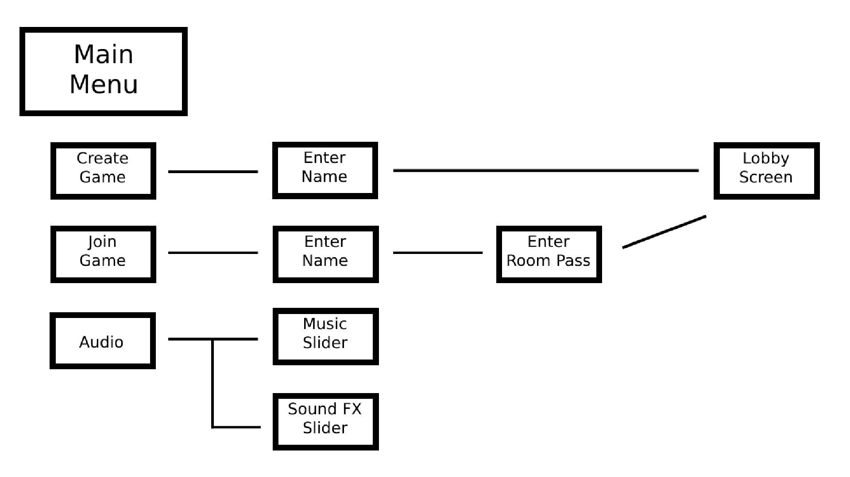

Design for the main menu, audio settings were cut from the final version.

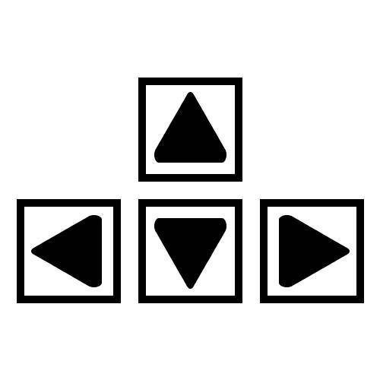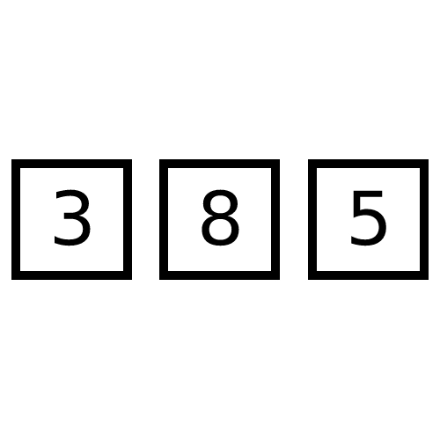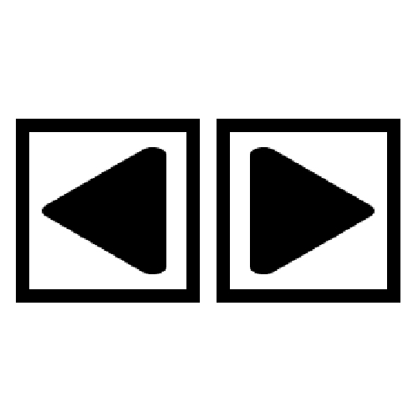

Concepts for buttons which would be used on the puzzles themselves.